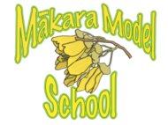
Mākara Model School
Board of Trustees Meeting
3 April 2024 at 5.30 pm

Where | Mākara Model School and Zoom
Trustees | Ali Kirkpatrick (Chair), James Ryan and Rachael Kasa
Attendees | Caro Wills (Principal), Andrew Graham (Deputy Principal)
Apologies | Genieve Morrison

Welcome
Ali welcomed everyone to the meeting. The meeting opened with a Karakia.

2. Administration
2.1 Apologies

The Board noted Genieve Morrison’s apology.

2.2 Declaration of Interests

The Board had no interests to declare that were relevant to the agenda.

2.3 Confirmation of Minutes 28 February 2024

The meeting confirmed the minutes of the meeting on 28 February 2024 as a true and accurate record and agreed to publish them on the school website.

2.4 Matters arising from the Minutes

There were no matters arising from the Minutes.

Actions

The Board noted that all outstanding actions had been completed.

3. Monitoring

3.1 Health & Safety
The Board noted that there were no health and safety incidents to report.

Principals Report

The Board thanked Caro for her thorough report and noted:

Assurances

The 2024 assurances were provided at the 24 February 2024 meeting.

School

The current roll for the school is 83 (including pre-enrolments) with an expectation that the roll will be around 90 by end of the year.

The teaching staff is 5.8 rather than the funded 5.7. The additional 0.1 allows for extension and support programmes, teacher and PRT release.

Policies

The Reporting and Assessment and Cell phone policies have been updated.

Curriculum and Educational results

The PAT assessment for Week 3 of Term 1 shows that students across all age groups are doing well in reading and listening comprehension and mathematics.

The results provide teachers with an understanding of student needs, areas of focus and resourcing requirements.

The Maths PLD will run for the next four terms.

The one hour a day for Reading, Writing and Maths continues with a shared school wide timetable. The ERO/Ministry completed a compliance interview and provided favourable feedback about the school programmes and initiatives.

RTLit, RTLB and Learning Support applications are being made for those who need them. One RTLB and two IRF applications have been successful.

Kelly Sports will be running an eight week athletics programmes for the students in Junior and Senior school. This will be paid for by parents, as the school could not cover the cost.

Meet the Teacher

About 90% of parents/caregivers attended the Meet the Teacher, and Parent Information Evening. The remaining 10% have been contacted to arrange a suitable meeting time.

School environment

The drainage and leakage issues appear to be resolved. Cleaning drains is part of the maintenance schedule and a responsibility of the school.

Storage for the bathroom area has not yet been finalised.

The courts are now painted. Volley ball nets will be purchased and a quote for the poles has been requested.

Vegetable and garden beds are completed.

The top field is being weeded and flattened so that an obstacle course can be developed using upcycled materials. The course is likely to cost about $3000.

The Board acknowledged and thanked the community for their support and donations in improving the school environment.

Release of the Kiwi

There will be another release of kiwi on 12 April 2024. A powhiri at the local marae will be held before the kiwi are released.

Karearea will attend the release with Capital kiwi and the iwi, with a live stream to each of the other classrooms.

The release will be celebrated by a hangi (the school community and local businesses have been asked to donate the food).

Grants

Grant applications are being submitted for new bikes. Although the current bikes have sound frames, mechanically they need maintenance, and there is a need for new stock.

Action: Ali to discuss options for restocking and maintaining bikes with the bike recycling group.

Finance Report

The Board thanked Caro for the Financial Report.

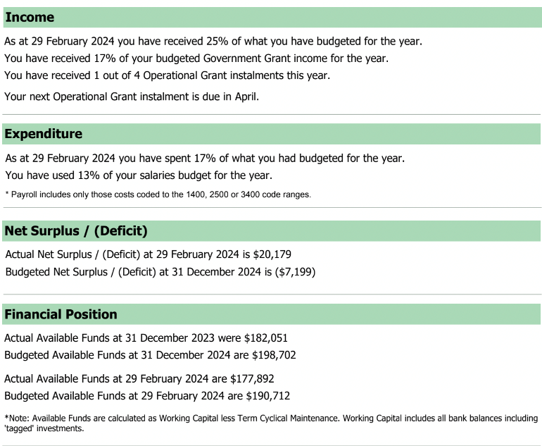

The Board noted:

Currently, the school is in surplus by $20,179.

The projected budgeted funds at 31 December 2024 are $198,702 compared to $182,051 at the same time last year.

At the end of February 2024, the school had forecasted available funds of $190,712, however the actual available funds at were $177,892. The difference being that the court is considered an asset and is therefore not included in the budget.

The Courts were funded by the following contributions:

Funder | Contribution
The Ministry | $28,700
Meridian | $15,000
NZCT | $20,000
Four Winds | $16,000
Board of Trustees  Line marking | $16,000  $3,000

Board Code of Conduct

The Mākara Model School Board Governance Guidelines was last reviewed in 2021. The guidelines need to be rewritten as a Code of Conduct and refreshed to align with school policies and delegated authorities and reflect the Board’s Te Tiriti responsibilities.

Action: Ali to liaise with Geneive re drafting a Code of Conduct for the Board that aligns with policies, authorities and adheres to the school’s Te Tiriti responsibilities.

Standing Items

The Board noted:

The Term One Policy review will be discussed at the next meeting.

No complaints have been received.

The next Board meeting will be on 15 May 2024 at 5.30 pm.

In-committee items

The Board discussed an in-committee item.

Meeting closed

The Chair thanked everyone for attending and closed the meeting with a Karakia at 7.00 pm.
Chair  Ali Kirkpatrick | Date

