
Mākara Model School
Board of Trustees Meeting
15 May 2024 at 5.30 pm
Where | Mākara Model School and Zoom
Trustees | Ali Kirkpatrick (Chair), James Ryan, Genieve Morrison and Rachael Kasa
Attendees | Caro Wills (Principal), Andrew Graham (Deputy Principal), Denise Hutana (minutes)

Welcome
Ali welcomed everyone to the meeting. The meeting opened with a Karakia.

2. Administration
2.1 Apologies

There were no apologies.

2.2 Declaration of Interests

The Board had no interests to declare that were relevant to the agenda.

2.3 Confirmation of Minutes 3 April 2024

The meeting confirmed the minutes of the meeting on 3 April 2024 as a true and accurate record and agreed to publish them on the school website.

2.4 Matters arising from the Minutes

There were no matters arising from the Minutes.

Actions

The Board discussed the actions (see Action table for updates).

Decision Register

The Board made the following decisions at this meeting.

Number | Agenda Item | Decision
1 | 3.2 | The Board agreed that three ballot spaces would be available in Term 3 for out of zone students and these would be advertised on the website.
2 | 3.2 | The Board agreed that the number of ballot spaces available would be a standing item for each Board meeting.
3 | 3.2 | The Board agreed that the school will hold two camps in Term Four (1) Karearea Class at Kaitoke and (2) Kiwi Class at El Rancho.
4 | 4 | The Board agreed to support the top field redevelopment through fund raising activities but did not commit to any level of funding required.

3. Monitoring

3.1 Health & Safety
The Board noted:
- There were no health and safety incidents to report.
- The health and safety policy is currently being updated.

Principals Report

The Board thanked Caro for her report.

Enrolments

The Board noted:

The school roll is 85 (16/5/24) and by the end of the year it is expected to be 90 (including pre-enrolments).

The Ministry has cut funding by $10,000 (as the roll is 10 less than expected). Caro is meeting with the Ministry tomorrow to discuss as it is difficult to manage unexpected budget line changes.

The Board is required to decide if out of zone students will be accepted and to advertise the number of available ballot spaces on the website. If, the number of applications exceeds places, then a selection process is required.

Decision: | The Board agreed that three ballot spaces would be available in Term 3 for out of zone students and these would be advertised on the website.
Decision: | The Board agreed that the number of ballot spaces available would be a standing item for each Board meeting.

Action: Ali to add “ballot spaces” as a standing item on to the agenda.

Curriculum

Professional learning and development for Maths continues with dedicated staff meetings and a Maths tutor working alongside teachers in the classroom.

Kapa Haka begins soon, with Wellington College and Wellington Girls College supporting Tamariki.
- Support and extension timetable is continuing to work well and includes an ESOL programme, RTLit, RTLB and Learning Support, Lego therapy, art, seasons of growth and mindfulness sessions.

Bikes - The Board noted that the bikes at the school are now fit for purpose. The Council have removed five bikes which will be replaced.

Information evening - The next information evening will be held on 27 June 2024 and will include a discussion on “emotional regulation” combined with the Matariki celebration.

Bell system - The Board considered the replacement of the bell system (currently a bell is manually rung by students walking around the school grounds) to be a low priority. Quotes for a system that includes contact between classrooms have been received, but are considered too expensive.

After School Care - Numbers attending the after-school care programme have reduced (eg due to sport activities) and the income is just covering costs. The Board will monitor numbers closely and consider the programmes viability going forward at each meeting.

Teacher Only Day will be held on 31 May 2024. The teachers will attend a professional development day at Wellington College which will include handwriting, cultural responsiveness and structured literacy.

Sustainability – Wellington City Council has visited the school to see the donated plants. The Council has donated an additional 80 plants that will be planted shortly.

School Camp – This year, the school will hold a camp for Karearea at Kaitoke and for Kiwi camp at El Rancho. Planning has begun for two camps in Term Four.

Decision: The Board agreed that the school will hold two camps in Term Four (1) Karearea Class at Kaitoke and (2) Kiwi Class at El Rancho.

Principal Assurances
The Board noted the Principals’ assurances for Term 2:
- Safety Checking and Police Vetting
- Teacher Registration and Certification
- Performance Management
- Appointment Procedure, Staff Conduct and Professional Development
- Equal Employment Opportunities
- Child Protection and Abuse Recognition and Reporting
- Curriculum and Student Achievement Policy
- Cellphones and Other Personal Digital Devices.

Finance Report

The Board thanked Caro for the Financial Report and noted that with the reduction of funding from the Ministry of $10,000 the school would not be in deficit.

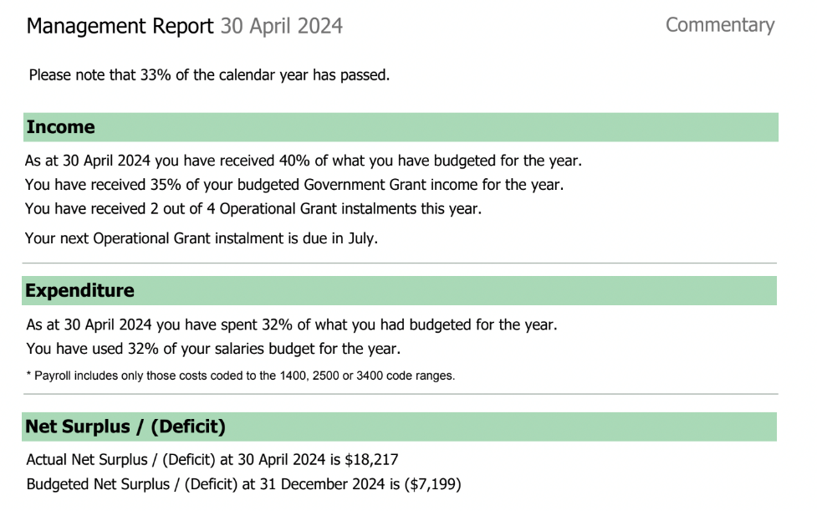

Grants - The Board noted grants have been approved for kapa haka uniforms ($4,500) and the vegetable garden ($500).

Top Field Redevelopment - The Board discussed the planned work to flatten the top field and make it appropriate for sport activities and noted:

The top field will be funded by a generous donation from whanau, grant applications and fund raising activities.

Currently, quotes are being requested and include a price for scraping off the top level, rebanking the sides, drainage and resowing grass.

Transpower will consider the grant application, once the project is ready to go, and other funding streams have been confirmed.

The work should provide an all-season playing area.

The Board agreed that there were no other pressing capital needs, and noted that grants are also being applied to cover the junior playground and the deck.

Decision: The Board agreed to support the top field redevelopment through fund raising activities but did not commit to any level of funding.

Strategic Items

Kāhui Document

Caro shared the CRP Framework with the Board and noted the framework includes four articles:

Kawanatanga: Honourable governance and leaderships.

Rangatiratanga: Retaining sovereignty, autonomy, voice and agency.

Oritetanga: Equitable Outcomes.

The Spoken Promise: The right to have religious freedom.

The Board noted:

The Kāhui assesses each school and considers the strengths of Mākara Model are Kawanatanga and Oritetanga.

The framework is a tool to help the Board develop the Schools’ strategic goals.

James Who?? has offered to attend a Board meeting to discuss the framework further.

Feedback from the Board will help to develop the next steps to enable the School to move to the next level.

On 31 May 2024 staff will discuss the Kāhui document and consider how the School should be rated and develop goals. These will be presented to the Board.

Strategic aims and targets

The Board noted:

The three strategic aims (strengthening cultural sustainable practices, every student achieves their best in all areas of the curriculum, growing connections values and wellbeing) align with the Kāhui articles.

Meaningful quantitative and qualitative measures (eg setting the baseline, actual and expected) are needed to show that the School is progressing towards the goals.

The Board will discuss the measures at their next meeting. This will include adding goals, baseline and expected measures to the articles in the Kāhui document.

Some of the aims such as “growing connections, values and wellbeing” will be difficult to measure.

The Board acknowledged the workload required to set baseline measures, expectations and develop tools to monitor progress and requested that the measures are meaningful, purposeful and outcome focussed.

Action: Board members to provide feedback to the Principal, on what they consider should be the priorities for measurement progress towards the Kāhui activities and strategic aims.

Standing Items

6.1 Term Two Policy Reviews
The Board agreed that the Term Two Policy reviews (Appointment Procedure and Safety Check) would be finalised at the next Board meeting.

6.2 Board Code of Conduct

The Board acknowledged that the Code of Conduct still needs work and would be considered at the next Board meeting.

Action: Ali and Geneive to incorporate the Board’s suggestions in the draft Board Code of Conduct for discussion at the next Board meeting.

6.4 Complaints Register

No complaints have been received this term.

Administration
7. 1 Action items

The Action table has been updated.

7.2 Agenda Items for Next Meeting

The Board identified the following items for discussion at the next meeting:
- Article 1 Kāhui document.
- After school care.
- School enrolments – ballot spaces available.
- Strategic aims and measurement.
- Draft Board Code of Conduct.
- Term Two Policy Reviews (Appointment Procedure and Safety Check).
- Governance.

In-committee items

The Board had in-committee time.

Meeting closed

The Chair thanked everyone for attending and closed the meeting with a Karakia.
Chair  Ali Kirkpatrick | Date

