
Mākara Model School
Board of Trustees Meeting
4 December 2024 at 5.30 pm
Where | Mākara Model School and Zoom
Trustees | Ali Kirkpatrick (Chair), Genieve Morrison, James Ryan, Joe Coyle and Rachael Kasa
Attendees | Caro Wills (Principal), Andrew Graham (Deputy Principal), Denise Hutana (minutes)

1 Welcome
Ali welcomed everyone to the meeting. The meeting opened with a Karakia.

2 Administration
2.1 Apologies

There were no apologies.

2.2 Declaration of Interests

The Board had no interests to declare that were relevant to the agenda.

2.3 Confirmation of Minutes 30 October 2024

The Board agreed to send any comments on the minutes for the meeting on 30 October 2024 to Ali. The minutes of the meeting will be published on the school website before the end of the school year.

2.4 Matters arising from the Minutes

There were no matters arising from the Minutes.

2.5 Actions

The Board discussed the actions (see Action table).

2.6 Decision Register

The Board made the following decisions at the meeting.
Number | Agenda Item | Decision | Moved/Seconded
1 | 7 | The Board unanimously agreed that Joe Coyle be appointed as Chair of the Mākara Model Board of Trustees for 2025. | Ali/James

3. Monitoring

3.1 Health & Safety
The Board noted that there has been one playground incident on 4 December which required a visit to the medical centre.

3.2 Principals Report

The Board thanked Caro for her report and noted:

School Roll and Staffing

The school roll currently sits at 92 (once year 8 students leave the roll will drop to 84).

The role allows the school to comfortably sustain the 4th teacher, plus CRT release.

The staffing and class lists are set for 2025 and will be shared with whānau on 10 December.

A 0.1 staffing extra has been approved by the Ministry for structured literacy funding.

The AOV and Ministry documents are up to date and ready to be submitted in March 2025.

Confirmation of dates for 2025

The school will open on 3 February 2025 and finish on 18 December 2025. Dates have been released to the community.

Curriculum

Harold the Giraffe is coming to the school on 9 December. All classes will attend a session which focusses on change and resilience.

Maths resources have been ordered. A joint Mākara and Karori Normal School application is being put forward for maths PLD as 20 staff are required for an application.

Reports will be sent out on 10 December.

3.3 Principal Assurances

The Principal has provided Term 4 2024 Assurances at the previous Board meeting.

4 Finance Report

The Board thanked Caro for the Financial Report and noted:

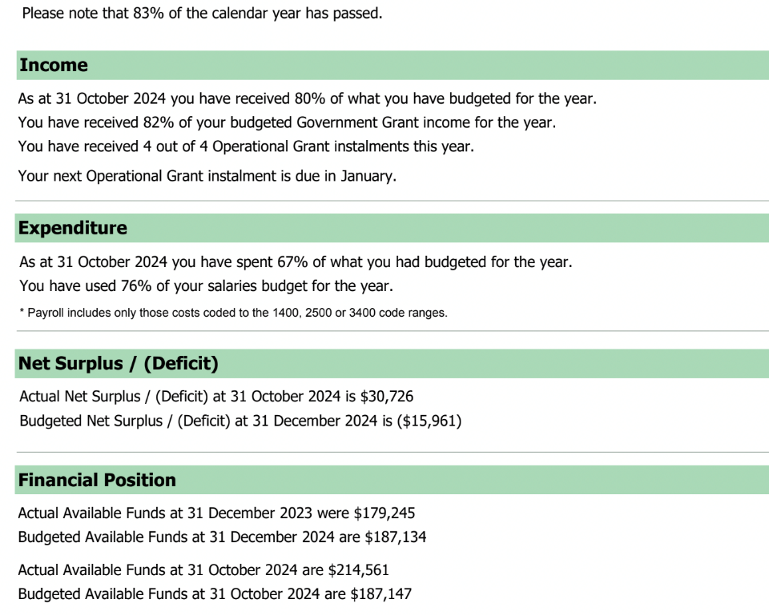

Financial year to Date

The Colour run and Market Day raised over $5,000 (to be confirmed).

83% of the school year has passed and 67% of the budget has been spent.

As of 31 October 2025, the school had a surplus of $30,726.

The budgeted funds for the end of 2024 is $187,154 compared to the actual funds at the end of October of $214, 561 (excluding $15,000 for top field levelling and reseeding and $10,000 recruitment fees).

Action: Caro to confirm that only items valued at $500 or more should be included in the Asset Register.

2025 Draft Budget

The draft budget will be presented to the Board early next year.

Currently, the draft budget is estimating a deficit of about $38,243 (includes a conservative estimate of the cost of the 5th teacher for about 2 days a week to cover release and sickness and also $6,000 for professional development and learning for the Principal).

According to the Ministry’s accountant the school is in a healthy position, and can afford additional projects next year should the Board agree.

5. Strategic Decisions

5.1 Mihi Whakatau 2025

Discussions have begun on the transition for the new Principal.

A dual powhiri is being planned in Week 2 of Term 1 2025.

Mākara students will be bussed to Karori Normal School for Caro’s powhiri.

Students from Karori Normal School will travel to Mākara for James’s powhiri.

6. Standing Items
Term 4 Policy Review

The following policies have been reviewed in Term Four:
- Finance and Asset Management Policy.
- Managing Income and Expenditure.
- Financial Conflicts of Interest.
- Asset Management and Protection.

6.2 Complaints Register

No complaints have been received this term.

7. Other Business

7. 1 Action items
The actions in the table were updated.

7.2 Identify Agenda Items for Next Meeting
No items were identified for the next meeting.

7.3 Board Chair

Motion: Joe Coyle be appointed as Chair of the Mākara Model Board of Trustees for 2025.

Moved: Ali Fitzpatrick Seconded: James Ryan ALL AGREED

7. In-committee items

The Board met in-committee.

8. Meeting closed

The Chair thanked everyone for attending and closed the meeting with a Karakia.

The meeting closed at 6.15 pm.
Chair | Date

