
Mākara Model School
Board of Trustees Meeting
19 June 2024 at 5.30 pm
Where | Mākara Model School and Zoom
Trustees | Ali Kirkpatrick (Chair), James Ryan, Genieve Morrison and Rachael Kasa
Attendees | Caro Wills (Principal), Andrew Graham (Deputy Principal)
The meeting was recorded for minute taking purposes.

1 Welcome
Ali welcomed everyone to the meeting. The meeting opened with a Karakia.

2 Administration
2.1 Apologies

There were no apologies.

2.2 Declaration of Interests

The Board had no interests to declare that were relevant to the agenda.

2.3 Confirmation of Minutes 15 May 2024

The minutes of the meeting on 15 May 2024 were confirmed as a true and accurate record and the Board agreed to publish them on the school website.

2.4 Matters arising from the Minutes

There were no matters arising from the Minutes.

2.5 Actions

The Board discussed the actions (see Action table for updates).

2.6 Decision Register

The Board made the following decisions at this meeting.
Number | Agenda Item | Decision
1 | 3.2 | The Board agreed to implement a timesheet system for part-time staff (including maintenance personnel) to better track hours worked and ensure accountability.
2 | 3.2 | The Board agreed to wait for the decision on the Four Winds grant application before making a decision on the development of the top field.

3. Monitoring

3.1 Health & Safety
The Board noted there were no health and safety incidents to report.

3.2 Principals Report

The Board thanked Caro for her report and noted:

School Roll and staffing
- Currently, 85 students are enrolled and this is close to the threshold for additional funding. Should roll numbers drop there potentially will be a need to adjust staffing levels.
- Caro is applying for a Kahui Ako position and has an interview on 1 July.

Decision: The Board agreed to implement a timesheet system for all part-time staff, including maintenance personnel, to better track hours worked and ensure accountability.

Action: Caro to implement a timesheet system for all part-time staff.

Curriculum
- The change of teachers for Tui class has gone smoothly.
- The Arts program is continuing.
- MSPRD (math program) is progressing well and the school is considering implementing Prime Maths next year (a more structured approach to teaching mathematics).

Strategic
- Currently the school is aligning Kahui goals with school strategic aims.
- The Board of Trustees consultation is scheduled for next Thursday.
- Connections with local colleges is progressing well.

Property
- The bike project is approximately 75% completed.
- A quote has been received for developing the top field. In addition to grant funding, donations and a Board contribution could be used to complete the project.

Decision: The Board agreed to wait for the results of the Four Winds grant application before deciding on the top field development.

3.3 Principal Assurances

The Principal provided Term 2 2024 Assurances at the meeting on 15 May 2024.

3.4 Finance Report

The Board thanked Caro for the Financial Report and noted:
- Despite losing $20,000 in funding from the Ministry, the school is still tracking towards a surplus.
- The projected available funds at year-end have been revised from $201,000 to approximately $195,500-$198,000.

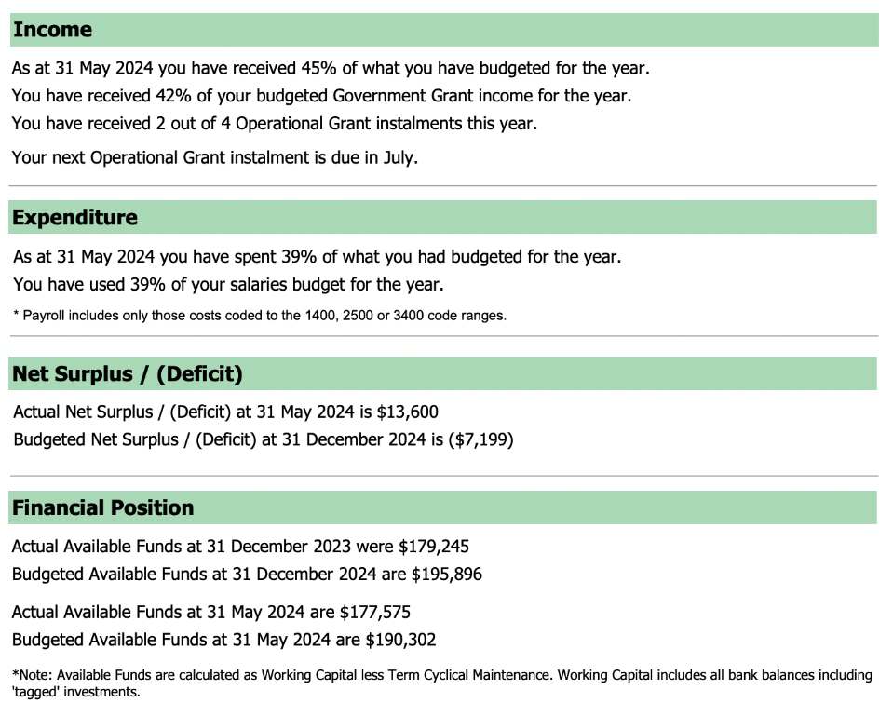

4. Strategic Items
4.1 Development of the top field

The Board noted:
- A new quote has been received for the development of the top field and is significantly lower than the initial quote.
- Funding could be sourced from grants, donations and a Board contribution.
- The bike track and the ongoing bike project is approximately 75% complete.
- The Principal is currently seeking quotes and grant funding for the junior playground.

Decision: The Board agreed to delay the decision on the development of the top field, until the outcome of the Four Winds grant application is known.

5. Standing Items
5.1 Term Two Policy review
The Board noted the following policies have been reviewed:
- Appointment Procedure.
- Safety Check.
- Makara Model School Board Governance Guidelines.

5.2 Complaints Register

No complaints have been received this term.

6. Administration
The Action table has been updated.

7.2 Agenda Items for Next Meeting

The Board identified the following items for discussion at the next meeting:

7. In-committee items

The Board had in-committee time.

8. Meeting closed

The Chair thanked everyone for attending and closed the meeting with a Karakia.
Chair | Date

